**18EEO301T- SUSTAINABLE ENERGY KEY**

**B.TECH – NOV 2022 EXAM – DOE – 23.11.2022 FN**

**PART A ( 1* 25 = 25)**

1. C.Declination angle.

2. B.Different molecules selectively absorb the radiation of different wavelengths.

3. B.A current source controlled by flux of radiation.

5. D.Diffused radiation

6. D. 5 to 25 m/s.

7. B.Wind speed.

8. A.Temperature

9. A.Land mass rises faster than water mass.

10. B.Run faster.

11. A. 7 % – 9 %

12. A.Sugar Cane

13. A.Batch Process.

14. D.Night soil

15. A.Is more efficient

16. B.Kaplan Turbine

17. A. 2-3 %

18. C.Mechanical Energy

19. D.Water depth is more than about half the wavelength.

20. B.5 Meters

21. C.High efficiency.

22. D.MCFC

23. D.The output voltage decreases.

24. C.Through steam referring of methane.

25. A.100 %

**PART B (5 * 10 = 50)**

26.A

….10 marks

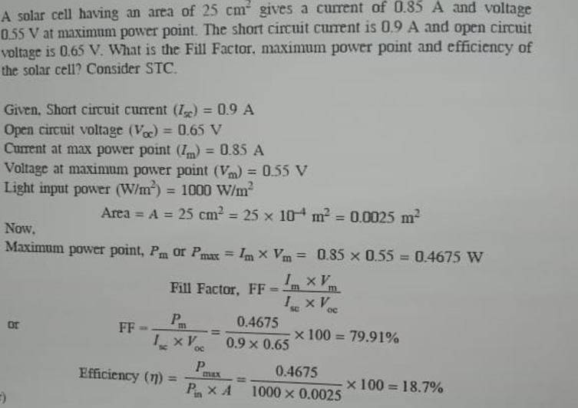

26.B

(i) Tile angle: ….2marks

The “tilt angle” or “elevation angle” **describes the vertical angle of your solar panels**.

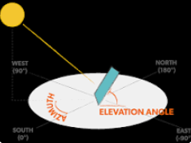

(ii) Azimuth angle : ….2marks

Solar azimuth angle is defined as **the angle between the projection of sun's centre onto the horizontal plane and due south direction**.

(iii) Hour angle: ….2marks

The hour angle is **the angular displacement of the sun east or west of the local meridian due to rotation of the earth on its axis at 15° per hour with morning being negative and afternoon being positive**. For example, at 10:30 a.m. local apparent time the hour angle is −22.5° (15° per hour times 1.5 hours before noon).

(iv) Declination angle: …..2marks

The solar altitude angle measured at noon will differ from the corresponding equinocial angle by an angle of **up to ± 23° 17'**. This angle is called the solar declination. It is defined as the angular distance from the zenith of the observer at the equator and the sun at solar noon.

(v) Solar Altitude angle: …2marks

The solar altitude angle is **0 degree at sunrise and usually 90 degrees when the sun is overhead at noon**.

27.A

….10marks

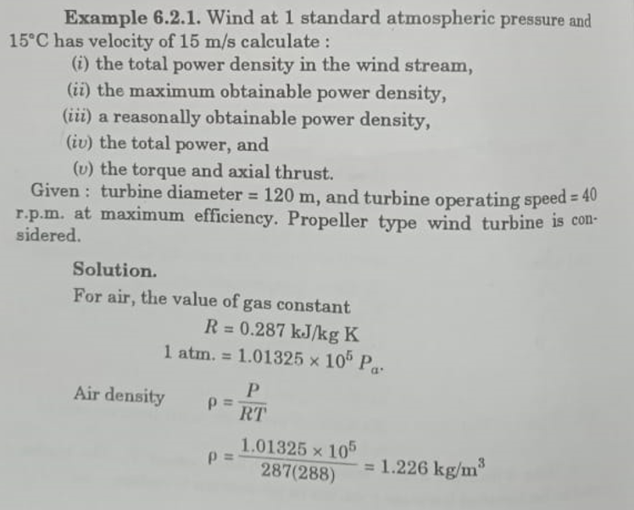

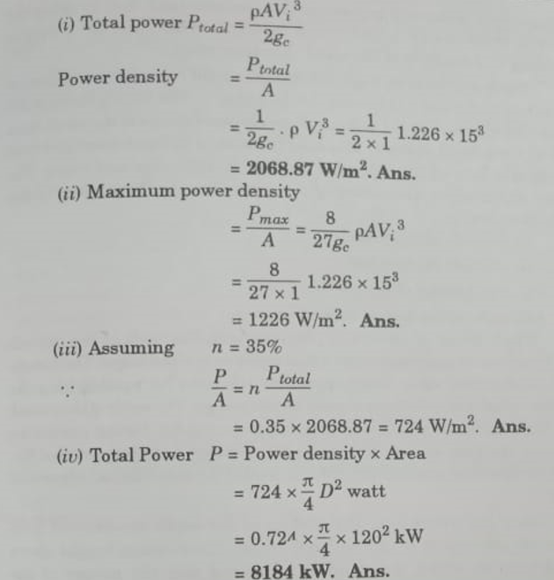

27.b ….5marks

HAWTs are **the most common wind machine designs in use today**. HAWTs utilize aerodynamic blades (i.e. airfoils) fitted to a rotor, which can be positioned either upwind or downwind. HAWTs are typically either two- or three-bladed and operate at high blade tip speeds.

…5marks

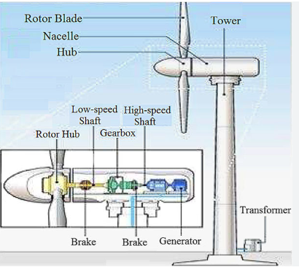

28 .a

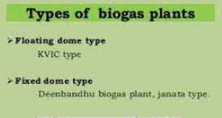

Floating dome type : ….5marks

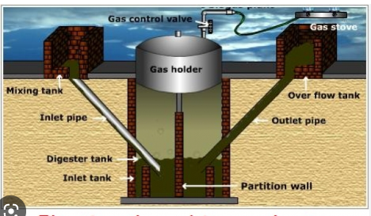

Fixed Dome type : ….5marks

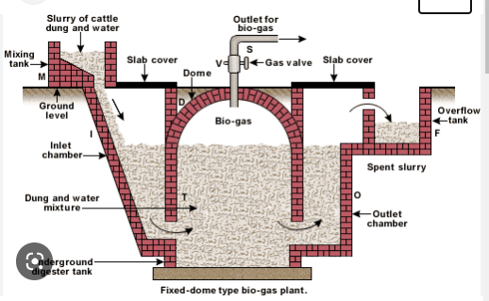

28.b

(i) Factors affecting biogas digestion: ….5marks

**Temperature is the important factor which affects the biogas production**. At higher temperature, maximum biogas is produced. There are other factors like the C/N ratio, pH value, compression ratio, and thetotal solid concentration whichare affecting the biogas production.

(ii) Cofiring ….5marks

Cofiring is **a near term, low-cost option for efficiently and cleanly converting biomass to electricity by adding biomass as a partial substitute fuel in high-efficiency coal boilers**. It has been demonstrated, tested, and proved in all boiler types commonly used by electric utilities.

29.a

Open loop system for Ocean energy. ….5marks

In an open-loop system, **the working fluid is water vapor produced directly from seawater**. It is considered “open” because the working fluid leaves the boundary of the system after performing work, that is the working fluid is returned to the ocean. Open-cycle systems don't need refrigerant, just warm and cold seawater.

….5marks

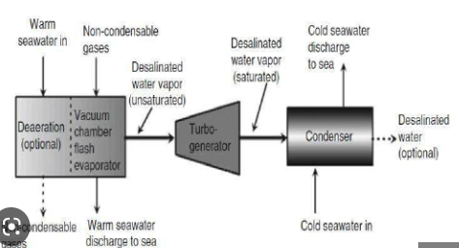

29.b

(i) Double basin Tidal energy conversion: ….5marks

Double Basin Tidal Power Plant Working:

**The water level in the upper basin is maintained above the level of water in the lower basin**. The upper basin is filled with water during high tide, and the lower basin is evacuated during the low tide. Therefore, a permanent head is produced between the upper and lower basins.

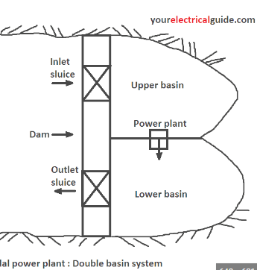

(ii) Site selection for tidal power plant: ….5marks

a.Geographical local should aid the generation of power from tidal.

b.Transport for constructing the plant .

c.Pay back period .

d.Initial cost for construction of plant.

e.Power Evacuation.

30.a ….5marks

Phosphoric acid fuel cell (PAFC) **anodes accelerate the hydrogen oxidation reaction rate in phosphoric acid**. The anode materials must be stable at high operating temperature in phosphoric acid. During operation, hydrogen starvation may cause reverse polarization and electrochemical corrosion of the anode material.

….5marks

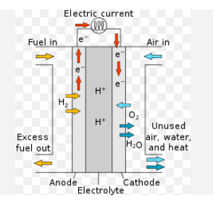

30.b

(i) Fuel cell performance characteristic : ….5marks

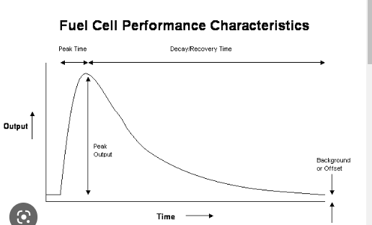

(ii) ….5marks

Hydrogen Extraction.

Investment is Required.

Cost of Raw Materials.

Regulatory Issues.

Overall Cost.

Hydrogen Storage.

Infrastructure.

Highly Flammable.

--------------------------------------The End----------------------